END OF TERM III EXAMINATION 2023

PRIMARY SIX

SOCIAL STUDIES AND RELIGIOUS EDUCATION

Time allowed: 2hours 15minutes

NAME … … … … … … … … … … … … … … … … … … … … … … … . … … … … … … … … …

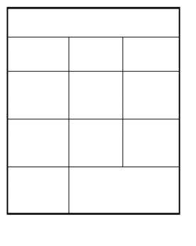

|  |
| --- |
| FOR EXAMINER’S USE ONLY  .  SECTION MARKS INIT.  **A**  **B**  **Total** |

|  |
| --- |
| 1. This paper has two sections A and B.  2. Section A has 40 questions (40 marks).  3. Section B has 15 questions (60 marks).  4. Answer all questions: all answers to both Sections A   and B must be written in the Space provided.  5. All answers must be written using a blue or black   ball point pen or ink but not pencil.  6. Any handwriting that cannot easily be read may   lead to loss of marks.  7. Unnecessary alteration of work may lead to loss   of marks.  8. Do not write anything in the box with examiner’s   use only |

**SECTION A**

1. Which instrument is used for measuring the height of place above sea level?

_________________________________________________________________________

2. How did Dr. Albert cook try to improve health services in Uganda?

_________________________________________________________________________

3. Give any one product of pyrethrum.

_________________________________________________________________________

4. Which game park would you advise a tourist to visit if he wants to see Ostriches?

_________________________________________________________________________

5. What did the raising of the union Jack (British flag) signify in Uganda in 1894?

_________________________________________________________________________

6. In the space below, draw the map symbol of a dam.

7. To which ethnic group do the Gala of Kenya belong?

_________________________________________________________________________

8. Give any one importance of trees in the school compound?

_________________________________________________________________________

9. What are agro – based industries?

_________________________________________________________________________

10. Name any one lake in East Africa that is found in the Western arm of the rift valley.

_________________________________________________________________________

11. Mention the main cash crop grown in Kerisho district in Kenya.

_________________________________________________________________________

12. Which country borders Uganda in the North?

_________________________________________________________________________

13. Give any one way in which democracy is practiced in schools.

_________________________________________________________________________

14. Matovu earns sh.500, 000 and spends sh. 300,000. What type of budget does he   
 have?

_________________________________________________________________________

15. Which group of foreigners introduced Islam in Uganda?

_________________________________________________________________________

16. Why are most game parks in East Africa located in the savannah grassland?

_________________________________________________________________________

17. Give any one economic disadvantage of mobile phones.

_________________________________________________________________________

18. Why is Africa referred to as the cradle land of man?

_________________________________________________________________________

19. Point out any one symbol of a school.

_________________________________________________________________________

20. What do we call the part of river Nile between Lake Albert and Nimule town?

_________________________________________________________________________

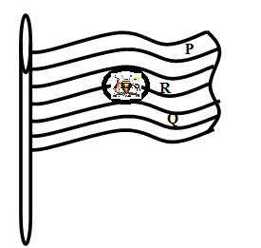**Use the diagram below to answer questions 21 – 23**

21. Why is the above flag sometimes flown as shown   
 above?

X _______________________________________________

22. Which symbol of Uganda as a nation is found at the part marked X?

______________________________________________

23. Name the colour marked with letter P.

______________________________________________

24. By what process were Block Mountains formed?

_________________________________________________________________________

25. How did the Christian Missionaries contribute towards to development of Uganda?

_________________________________________________________________________

26. Which African city is crossed by the Greenwich Meridian?

_________________________________________________________________________

27. How has the government of Uganda tried to solve the problem of cattle rustling among the pastoral tribes?

_________________________________________________________________________

28. If it is 6:00pm in Accra, What time is it at a place Y which is 300W of the Greenwich?

_________________________________________________________________________

29. Who was the leader of the Lamogi Rebellion in Northern Uganda?

_________________________________________________________________________

30. Apart from smartness, give any other reason why school children are encouraged to   
 wear uniform.

_________________________________________________________________________

31. Give any one example of a fibre crop.

_________________________________________________________________________

32. What type of wood is obtained from natural forests?

_________________________________________________________________________

33. Why is it not advisable to transport tomatoes from Uganda to Europe using water   
 transport?

_________________________________________________________________________

34. Why is Uganda called a landlocked country?

_________________________________________________________________________

35. Which lake is shared by all the three East African countries?

_________________________________________________________________________

36. State any one example of a renewable resource.

_________________________________________________________________________

37. In which way was the formation of Mt. Elgon different from that of Mt. Rwenzori?

_________________________________________________________________________

38. Why does Kalangala District receive convectional rainfall?

_________________________________________________________________________

39. Write down any one problem faced by farmers in East Africa.

_________________________________________________________________________

40. Why is the Stevenson’s screen painted white?

_________________________________________________________________________

**SECTION B**

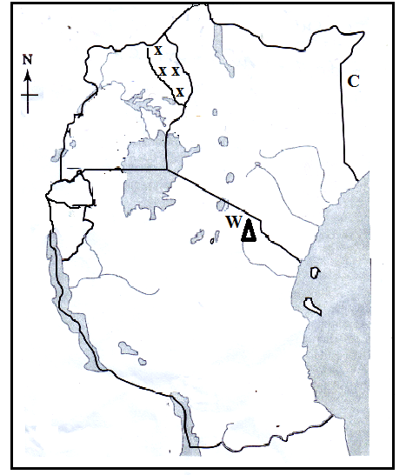41a) Use the map of east Africa given below to answer the questions that follow

a) Name the country marked C.

______________________________

b) Use letter Y to locate Rwanda on the above map.

c) Identify the mountain marked W

_______________________________

d) What is the main economic activity carried out in the area marked **xxxx** on the map?

_______________________________

42a) what do you understand by the term population distribution?

_________________________________________________________________________

b) Give any two reasons why the government of Uganda carries out population census?

i) _________________________________________________________________________

ii) _________________________________________________________________________

c) How can a high population be a disadvantage to a country like Uganda?

_________________________________________________________________________

43a) Point out the biggest game park in East Africa.

_________________________________________________________________________

b) How are game parks economically important to the governments of East Africa?

_________________________________________________________________________

c) What favours the presence of many mountain Gorillas in Bwindi impenetrable   
 National Game Park?

_________________________________________________________________________

d) How is poaching dangerous to the tourism industry?

_________________________________________________________________________

44a) What is the biggest ethnic group in East Africa?

_________________________________________________________________________

b) Give any two problems that were faced by the ethnic groups during their migrations.

i) _________________________________________________________________________

ii) _________________________________________________________________________

c) Identify any one cause of the collapse of the Chwezi Empire.

_________________________________________________________________________

45a) Where are the headquarters of the East African community located?

_________________________________________________________________________

b) Suggest any one reason why Burundi joined the East African community.

_________________________________________________________________________

c) Name the president of Tanzania who participated in the formation of the East African community.

_________________________________________________________________________

d) Apart from the East African community, mention any one other common market in   
 Africa.

_________________________________________________________________________

46a) What are latitudes?

_________________________________________________________________________

b) Give any one importance of the lines of latitude.

_________________________________________________________________________

c) Mention any two districts in Uganda that are crosses by the equator.

i) ______________________________________ ii)_____________________________

47a) How useful was a dog to early man?

_________________________________________________________________________

b) Which discovery marked the end of Stone Age period?

_________________________________________________________________________

c) State any one tool that was used by early man.

_________________________________________________________________________

d) What term is used to refer to the digging up of fossils?

_________________________________________________________________________

48a) Match the items in Group A with their uses in Group B

|  |  |
| --- | --- |
| Group A | Group B |
| i) Stevenson screen  ii) Wind sock  iii) Barometer  iv) Hygrometer | i) measures humidity  ii) Measures the strength of wind  iii) Measure air pressure  iv) Keeps delicate weather instruments |

i) Stevenson screen _____________________________________________________

ii) Wind sock __________________________________________________________

iii) Barometer ___________________________________________________________

iv) Hygrometer _______________________________________________________________

49a) Define the term fishing.

_________________________________________________________________________

b) State any two traditional methods of catching fish in Uganda.

i) _____________________________________ ii)__________________________________

c) How has the fishing industry contributed to the economic development of East   
 Africa?

_________________________________________________________________________

50.a) Give one reason why Kabaka Daudi Chwa did not sign the 1900 Buganda Agreement.

_________________________________________________________________________

b) Who signed the 1900 Buganda Agreement on behalf of the British government?

_________________________________________________________________________

c) Give any two results of the Buganda Agreement.

i) _________________________________________________________________________

ii) _________________________________________________________________________

51. Apart from being the first president of Kenya, give one other reason why Jomo Kenyatta is remembered in the history of Kenya.

_________________________________________________________________________

b) When did Uganda attain her independence?

_________________________________________________________________________

c) What was the first political party to be formed in Uganda?

_________________________________________________________________________

d) Give any one way how Africans suffered in their struggle for independence.

_________________________________________________________________________

52. What is vegetation?

_________________________________________________________________________

b) Identify the two types of vegetation.

i) _________________________________ ii)___________________________________

c) How is vegetation important to man?

_________________________________________________________________________

53. Write **LEGCO** in full.

_________________________________________________________________________

b) Why was **LEGCO** formed in 1921?

_________________________________________________________________________

c) Pint out any two of the first three Ugandans to be nominated to **LEGCO.**

i) ________________________________ ii)_______________________________

54a) Give any two basic human needs.

i) _______________________________ ii)_______________________________

b) Write down any one reason why it is difficult for people to get their needs.

_________________________________________________________________________

c) Identify any one place where basic needs can be got.

_________________________________________________________________________

55a) How is a magnetic compass useful to the pilots?

_________________________________________________________________________

b) Apart from pilots, mention any two other groups of people who use a magnetic   
 compass.

i) ________________________________ ii)________________________________

c) What term is used to refer to the four main directions of a magnetic compass?

_______________________________________________________________________________________